

**Department of Computer Science**

**COMP438**

**Title of Project:** Pharmacy application

**Group Members with IDs:**

Marwan Issa 1170704

Muhannad Khatib 1182694

Ishaq Rajab 1180085

Izat Awwad 1162508

**Abstract**:

Going to a pharmacy to buy a specific medicine, and when you arrive, you find that this medicine is unavailable, because this causes you frustration. If you go to buy a prescription and you do not know anything other than its name or information about it, then this causes problems

In the treatment application, we found a solution to these problems, which is first to display all medicines to the pharmacy on the application to know the available drugs and the possibility of paying through the application, and only all you have to do is reach the pharmacist and give the pharmacist the report or the prescription.

**Teamwork**:

**Izat Awwad:**

Build Contact Us activity (XML), Shared Preference and Remember me in login activity.

**Muhannad Khatib:**

Build Login activity (XML), Build Registration activity (XML), Build Product activity (XML), Build Checkout activity (XML).

**Ishaq Rajab:**

Build Lunch activity (XML), Registration & Login (Test Data) Backend, Shared Preference at Registration activity, add recycler in home page.

**Marwan Issa:**

Build a Home page (XML) and add a recycler view with a product to take it from making data, Rebuild Product activity (XML), the listener for the card in the recycler view to moving to the dynamic product page, Build the Cart activity and Rebuild the recycler view with the product you have and count the price to give the total, user can delete the product he has bought.

Design the whole app on Figma (**UX**/UI) and design a Logo.

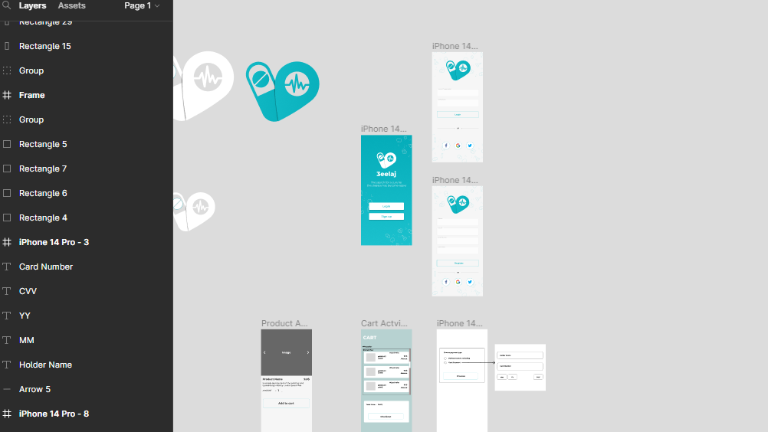

**Thanks**